**SLPS Accountability Plan Template 2021-2022**

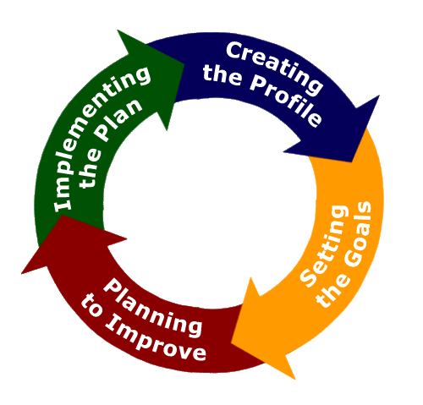

**The Accountability Plan Template embodies requirements set by the Missouri Department of Elementary and Secondary Education (DESE) relative to Schoolwide Planning and the completion of the Consolidated Application and Comprehensive School Improvement Plan. It also supports the continuous improvement of all St. Louis Public Schools.**

**We are committed to a Continuous Improvement System based on the Theory of Action: Improved student learning for every student in every school, with the primary goal of having all Missouri students graduate ready for success. This Accountability Plan Template has as its foundation the following five pillars of the SLPS Transformation 3.0 Plan, which support the Continuous Improvement Theory of Action:**

**Pillar 1: The District creates a system of excellent schools**

**Pillar 2: The District advances fairness and equity across its system**

**Pillar 3: The District cultivates teachers and leaders who foster effective and culturally responsive learning environments**

**Pillar 4: All students learn to read and succeed**

**Pillar 5: Community partnerships and resources support the District’s Transformation 3.0 Plan**

**Sumner High School**

**2021-2022 ACCOUNTABILITY PLAN TEMPLATE Table of Contents**

|  |  |
| --- | --- |
| **Section** | **Contents** |
| **1** | School Profile, Mission, Vision, School Improvement Planning Committee |
| **2** | Comprehensive Needs Assessment: Student Demographics; Student Achievement; Curriculum and Instruction; High Quality Professional Development; 2021-2022 Priorities; Root Cause Analysis; School Parent and Family Engagement: Program Evaluation Results; Policy Involvement; Shared Responsibilities for Student Achievement (School Parent Compact); School Capacity for Involvement; Summary Statements |
| **3** | The Goals and the Plan: Goal 1-Leadership Development Plan; Goal 2-Reading Plan; Goal 3-Mathematics Plan |

**SECTION 1**

**School Profile**

**Accountability Plan Template**

**(**[**DESE’s Consolidated Application**](https://dese.mo.gov/sites/default/files/qs-fc-Consolidated-Fed-Prog-Plan.pdf) **and** [**DESE’s LEA/School Improvement Guide**](https://dese.mo.gov/sites/default/files/LEA-School-Improvement-Guide-2019.pdf)**)**

|  |  |  |
| --- | --- | --- |
| **Improvement/Accountability Plan** | | |
| **Focus of Plan (check the appropriate box):**   * **LEA** * **School** | **Name of LEA: Dr. Sean Nichols, Principal**  **Name of School: Sumner High School**  **School Code: 698** | **Check if appropriate**   * **Comprehensive School  ***Requires a Regional School Improvement Team** * **Targeted School** * **Title I.A** * **Autonomous** |
| **Date:** | **5.17.21** | |
| **Purpose: To develop a plan for improving the top 3 needs identified in the needs assessment.** | | |
| **School Mission:** The mission of Sumner High School is to engage students in an all-inclusive, culturally responsive, and multigenerational education that will inspire them to remain lifelong learners and productive citizens | | |
| **School Vision:** The vision of Sumner High School is to leverage the legacies and traditions of the past to build an educational environment wrapped in afro-centric values, technology, and innovation to create future opportunities for students, as they become globally productive citizens who give back to their communities. | | |
| **One plan may meet the needs of a number of different programs. Please check all that apply.**   * **Title I.A School Improvement** * **Title I.C Education of Migratory Children** * **Title I.D Prevention and Intervention Programs for Children and Youth who are Neglected, Delinquent or At-Risk** * **Title II.A Language Instruction for English Learners and Immigrant Children** * **Title IV 21st Century Schools** * **Title V Flexibility and Accountability** * **Individuals with Disability Education Act** * **Rehabilitation Act of 1973** * **Carl D. Perkins Career and Technical Education Act** * **Workforce Innovation and Opportunities Act** * **Head Start Act** * **McKinney Vento Homeless Assistance Act** * **Adult Education and Family Literacy Act** * **MSIP** * **Other State and Local Requirements/Needs __________________________________________________________** | | |

**Districts, charters and/or schools should engage in timely and meaningful discussions, with a broad range of stakeholders, to examine relevant data to understand the most pressing needs of students, schools and/or educators and the potential root causes for each need. By inviting all stakeholders to participate in the needs assessment process you are establishing a unified understanding of the LEA and/or school(s), identifying goals that reflect the vision of the entire learning community and promoting buy-in for improvement efforts. The following chart identifies stakeholders who may participate in the needs assessment process.**

|  |  |  |  |
| --- | --- | --- | --- |
| **School Planning Committee** | | | |
| **Position/Role** | **Name** | **Signature** | **Email/Phone Contact** |
| Principal | Dr. Sean Nichols |  | Sean.Nichols@slps.org |
| Assistant Principal | Mr. Chris Crumble |  | Christopher.Crumble@slps.org |
| Academic Instructional Coach | Ms. Amanda LaBoo |  | Amanda.LaBoo@slps.org |
| Family Community Specialist | Ms. Qiana Smith |  | Qiana.Smith@slps.org |
| SPED Staff | Ms. Diane Navies |  | Diane.Navies@slps.org |
| ISS/PBIS Staff | Mr. Sylvester Dixson |  | Sylvester.Dixson@slps.org |
| Teacher | Mr. Conner Maguire |  | Conner.Maguire@slps.org |
| Teacher | Ms. Chaquill Merriweather |  | Chaquil.Merriweather@slps.org |
| Parent | Ms. Dominique Reed |  | Dominique.Reed@slps.org |
| Parent | Ms. Qiana Moore |  | Qiana.moore@slps.org |
| Support Staff | Ms. Jean Dodge |  | Jean.Dodge@slps.org |
| Community Member/Partner | Rev. Jerome Morris - St. James Church |  | (602)820-6754 |
| Network Superintendent | Dr. Crystal Gale |  | Crystal.Gale@slps.org |
| Other | Dr. Mary Anne Cook |  | jvcradiology@att.net |

**SECTION 2**

**Comprehensive Needs Assessment**

|  |  |  |
| --- | --- | --- |
| **Comprehensive Needs Assessment \***[**DESE’s Consolidated Application**](https://dese.mo.gov/sites/default/files/qs-fc-Consolidated-Fed-Prog-Plan.pdf) | | |
| **Student Demographic (Data pulled from SIS on 5.17.21)** | | |
| **Data Type** | **Current Information** | **Reflections** |
| **Student Enrollment as of 5/21** | 351 |  |
| **Grade Level Breakdown** | 9th - 68, 10th - 70, 11th - 46, 12th - 32 |  |
| **Ethnicity** | B - 97.8% W - 2.3% H - 0.9% |  |
| **Attendance** | 90/90 - 9.5% ADA 55.1% | (from Schoolzilla as of 5.19.21) |
| **Mobility** |  | Students with high mobility struggle with 90/90 attendance |
| **Socioeconomic status** | 100% | All of our students qualify for free and reduce lunch |
| **Discipline** | 1% | Virtual protocols allowed students to be sent home to complete classes virtually when necessary in lieu of OSS |
| **Limited English Proficiency** | .04% | Only 1 student currently enrolled receives ESOL services |
| **Special Education** | 50 Students | 23% of our students have IEP’s while Sumner designates only 2 certified special education teachers to teach this population. |

|  |  |  |
| --- | --- | --- |
| **Strengths** | **Weaknesses** | **Needs** |
| Discipline incidents decreased with the option of at home, virtual learning. Enrollment remained steady and growth is projected for the upcoming year. | Mobility and attendance: students with a history of attendance and challenging behavior placed at Sumner in addition to the layers of challenges the pandemic added for students and families. | Additional special education allocation to provide specialized, targeted instruction for students in each of the core content areas. |

|  |  |  |  |  |
| --- | --- | --- | --- | --- |
| **Student Achievement**  ***(Please analyze your achievement data for 20-21 and provide an explanation for the current performance data.)*** | | | | |
| **Goal Areas** | **19/20- Performance** | **21-22 Goal** | **Current Performance** | **Explanation/Rationale for Current Performance** |
| **ELA** | Spring 2018 Data: E2 Prof/Adv: 21.9%  2019 Data: 2609 (Below Basic Quartile) | 160 MPI | - CSA 3: 308 MPI  - CSA 4: 213 MPI - EOC completion is 93% | Limited participation and accountability due to the vast majority of students opting into the virtual structure for the entire school year. Assessments layered on top of assessments led to fatigue and lack of investment on the part of the students. |
| **Reading** | 2019 Data: 2609 (Below Basic Quartile)  140 MPI  42% student gains (via Fall to Winter Scantron)  40.6% of students meet or exceed 50th percentile with STAR Reading | 160 MPI | - STAR Reading: 11.4% reading at or above grade level | Less effective reading instruction was possible within the constraints of the virtual setting. Assessments completed at home do not have the levels of accountability as in person assessments. |
| **Math** | Spring 2018 Data: ALG Prof/Adv: 3.3%  2019 Data: 5321 (Basic Quartile) 57% student gains (via Fall to Winter Scantron) | 195 MPI | - CSA 3: 250 MPI  - CSA 4: 253 MPI - EOC completion is 95%  - 43.1% growth from Scantron BM1 to BM2 | Limited participation and accountability due to the vast majority of students opting into the virtual structure for the entire school year. Assessments layered on top of assessments led to fatigue and lack of investment on the part of the students. |
| **Science** | Spring 2018 Data: GOV Prof/Adv: 15.4%  2019 Data: See MPI | 160 MPI | - CSA 3: 200 MPI - EOC completion is 95% | Due to scheduling from previous year, only 24 students enrolled in bio this school year creating a very small sample. This along with being virtual and pandemic related attendance issues created challenges related to instruction as well as collecting data. |
| **Social Studies** | Spring 2018 Data: GOV Prof/Adv: 16.3%  2019 Data: See MPI | 123 MPI | - CSA 3: 373 MPI  - CSA 4: 170 MPI - EOC completion is 95% | Although the school was able to get 95% EOC completion, multiple students had limited participation and accountability due to most students opting into the virtual structure for the entire school year. Assessments layered on top of assessments led to fatigue and lack of investment on the part of the students. |
| **CCR** | Spring 2018 Data:   * 36.9% at or above state standard (CCR assessments) * ACT 2018 Composite: 14.4 |  | -ACT Composite Avg. Score is 12.4  -24.5% of students scored at or above state standard on CCR assessments | 2 AP courses added to course offerings for Sumner students in 20-21 with a 3rd slated for 21-22. |

\**Please include any data tables, charts, graphs, etc. to support your current performance below\**

|  |  |  |
| --- | --- | --- |
| **Strengths** | **Weaknesses** | **Needs** |
| * 42% of students made gains from Fall to Winter Scantron Assessment for **Reading** * 57% of students made gains from fall to winter Scantron Assessment for **Algebra** * **Government** EOC increase from 0% Prof/Adv in 2017 to 16.3% Prof/Adv in 2018. * Increase in students scoring at or above national **CCR** assessment average from 29.5% in 2016 to 36.9% in 2018 | * Gaps in learning exist from spring of 2020 as well as from the 20-21 school year because of the virtual structure and low levels of participation * Data acquired in 20-21 may not provide a complete picture due to the low levels of participation in some assessments as well as the at home environment in which the assessments were completed * No EOC data is available for 19-20 | * Professional development for: * **Ongoing** training with explicit reading, writing and math instructional strategies * Designing coherent lessons by unpacking top standards/skills on state/national assessments and aligning rigor in daily lessons * Responding to lack of standard mastery with culturally responsive learning strategies to deepen content knowledge. (Identifying what data-driven instruction LOOKS like) |

**Star Reading Data**

|  |  |
| --- | --- |
| **Student Reading at High School Level in August 2019** | **Students Reading at High School Level in December 2019** |
| 9th Grade 0% | 9th Grade 6% |
| 10th Grade 4% | 10th Grade 14% |
| 11th Grade: 3% | 11th Grade: 11% |
| 12th Grade: 14% | 12th Grade: 18% |

|  |
| --- |
| **Reading Star Data 2018-2019** |

|  |
| --- |
| 9th Grade 33.3%  10th Grade 26%  11th Grade: 22.2%  12th Grade: 18% |

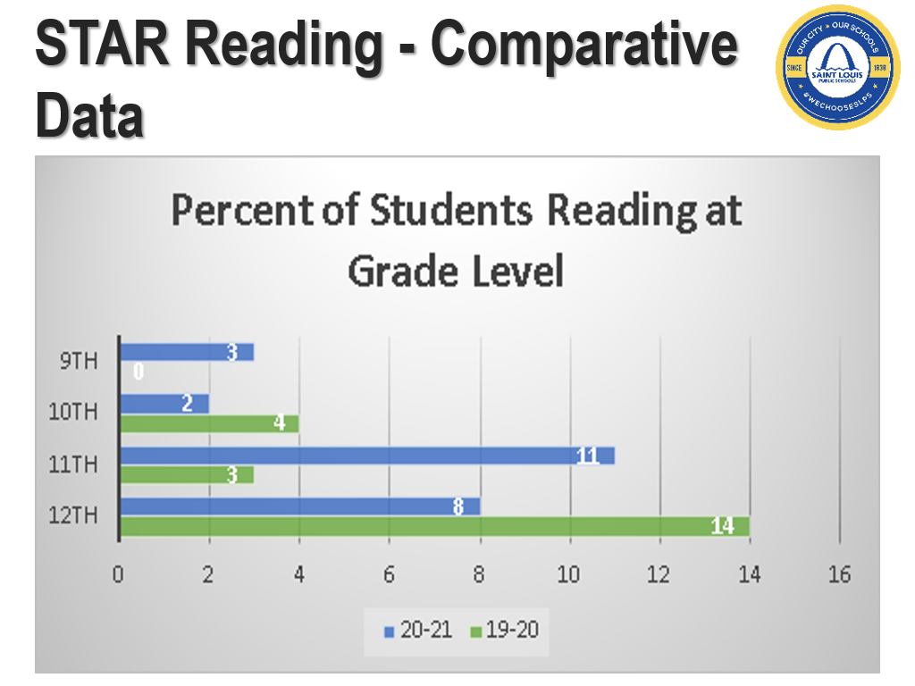

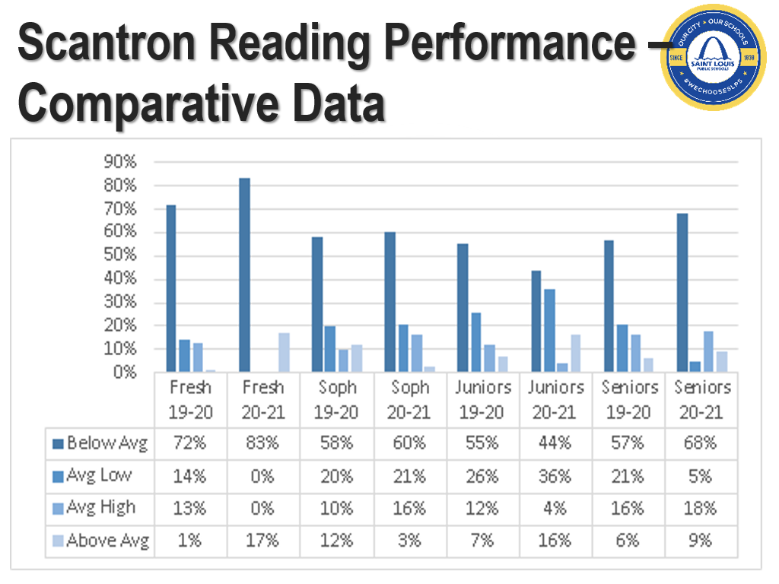

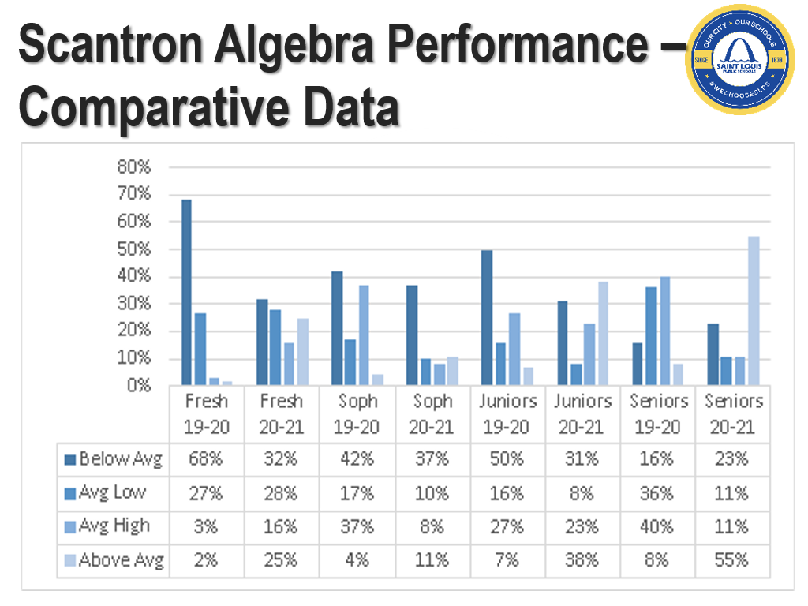

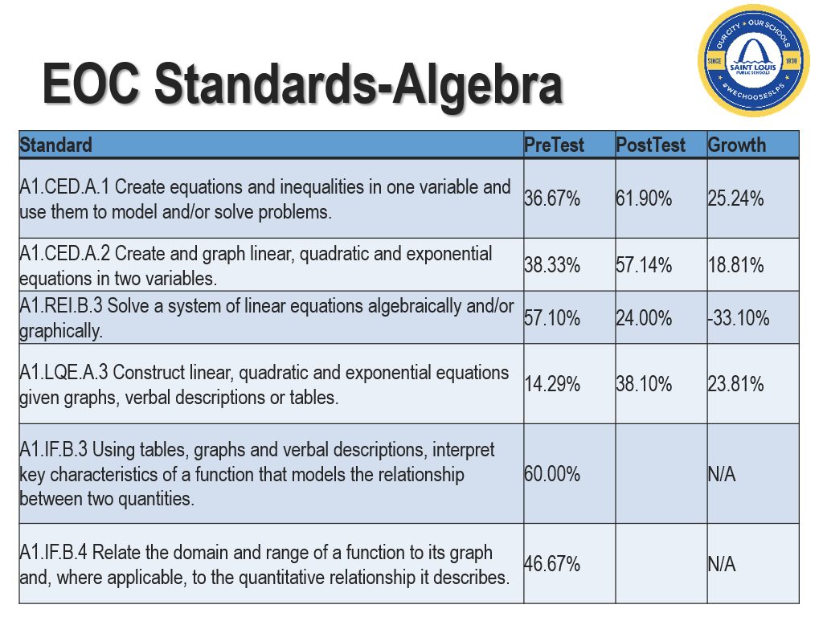

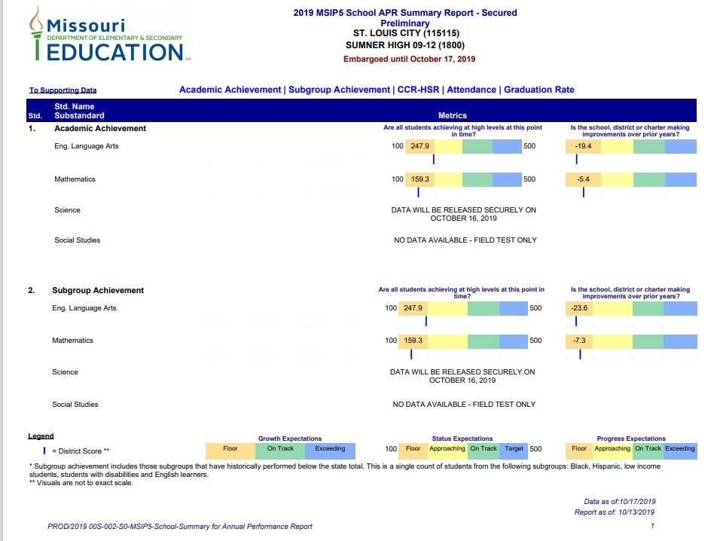

|  |  |  |
| --- | --- | --- |
| **Curriculum and Instruction**  ***(Please use the boxes below to describe how your school supports the following factors of curriculum and instruction)*** | | |
| **Data Type** | **Current Information** | **Reflections** |
| **Learning Expectations** | Data driven instruction, data analysis and instructional intervention plans during weekly PLC meetings, standard based instruction | Data was incomplete this year due to virtual and concurrent instruction as well as factors related to the global pandemic. Data not consistently used to drive instruction; PLC meetings stretch to engage teachers in collaborative efforts and are often less effective due to small teams and lack of overlap related to courses taught within teams. |
| **Instructional Programs** | Achieve 3000 - Literacy  Achieve 3000 - Math  IXL - Math | Teachers are not maximizing utilization of instructional programs. Pacing of core instruction, formative assessment, and remediation/reteaching usurps the majority of time in core classes leaving teachers struggling to find time to integrate instructional programs. Trainings offered outside of school hours and leading to fewer participants. Some resistance from teachers that were not familiar with the program. |
| **Instructional Materials** | District-issued curriculum maps with supporting textbooks, workbooks, and documents. | Teachers are not fully utilizing instructional materials teacher skill/will may be an underlying cause; no updated curriculum map for SPED functional curriculum courses leads to less robust instruction in those classes within which almost ¼ of our student population is enrolled. |
| **Technology** | Promethean boards, laptops, iPads, desktop computers | Increased usage of tech to support instruction because of the virtual instruction component. Tech based instruction also allowed for inequity when students did not have access for a variety of reason throughout the year. Some teachers utilized tech to maximize instruction. |
| **Support personnel** | Variety of identified staff | Assist with holistic support of the students and families to bridge the gap and enhance success. Community resources and engagement information is distributed ongoing. |

|  |  |  |
| --- | --- | --- |
| **Strengths** | **Weaknesses** | **Needs** |
| *-*Most teachers grew their practice related to tech integration to support instruction  -CFA and CSA’s available for variety of core contents and select teachers are utilizing assessments to drive instruction towards standard mastery | * Inequity related to student tech (missing, broken, withheld due to fines) caused challenges for students and teachers. * Selected data not utilized consistently to drive instruction * Instructional programs not utilized to capacity to support students * Consistent lack of teacher feedback on effective teaching, learning and grading strategies | * Accessible professional development related to instructional programs and a plan for integration that includes classes outside of ELA and math as well * Frequent celebration of student progress on bi-weekly formative assessments along with constructive feedback provided to students on a consistent basis * Teacher led data presentations to support implementation and accountability related to data utilization and fidelity of targeted instructional strategies w/admin feedback provided * Students take the lead in the own learning with ongoing support from the teacher |

|  |  |  |
| --- | --- | --- |
| **High Quality Professional Staff**  ***(How are you ensuring that all students are taught by a high-quality teacher?)*** | | |
| **Data Type** | **Current Information** | **Reflections** |
| **Staff Preparation** | Staff are provided with support and professional development individually and in small groups throughout the course of the year. Teachers are given an opportunity to set specific goals related to their growth as well as determine the focus of the support they are provided at the beginning of each school year. Standards based instruction training | All staff members receive a calendar of district/school meetings so that all staff members have an opportunity to plan for success. Teachers also have the opportunity to engage in coaching and individual professional development upon request at any time throughout the year with the AIC. |
| **Staff Certification** | 81% of teachers are certified in their subject area | One special education teacher resigned in September 2020 and was replaced with a permanent sub, one math teacher did not return from oversees for 2nd semester and classes are being taught by a permanent sub, music and social studies are also taught by permanent subs. Our chemistry teacher is in a certification program currently and should be fully certified by 21-22. |
| **Staff Specialist and other support staff** | 1 FCS; 1 ISS Monitor; 1 library aide; 2 Guidance Counselors; 1 Book clerk; 1 Nurse; 1 Assistant; 5 Security Officers; 1 School Social Worker, 1 secretaries | All staff specialists and support staff have multiple years of experience, a variety of credential which include diversified degrees, certifications, and licensures. |
| **Staff Demographics** | B- 28; W- 11 Female: 18 (46%) Male: 17 (54%) | The building is almost evenly split between male and female staff members and approximately 72% of the staff are African American. |
| **School Administrators** | Principal holds a Master’s Degree, Specialist Degree, and Doctoral Degree.  AP holds a Master’s Degree, a Specialist Degree, and a Reading Specialist Certificate.  AIC holds a Master’s Degree and a and Doctoral Degree. | Leadership team all have advanced degrees. |

|  |  |  |
| --- | --- | --- |
| **Strengths** | **Weaknesses** | **Needs** |
| New arts programming from outside agencies partnering with Sumner for the 21-22 school year should provide variety and opportunities for students that did not exist within the current framework. | Lack of certified staff in multiple classes. | Our school needs flexible scheduling to allow teachers to integrate more academic programming in the school to increase enrollment and attract more highly qualified staff. |

|  |
| --- |
| **21-22 Priorities Prioritized areas of *Need* for 21-22 based on needs assessment/data analysis** |
| **Leadership**: Improve instructional leadership by providing teachers with consistent and targeted instructional feedback from the entire leadership team to support the needs of teachers serving highly mobile students. |
| **Reading**: Develop a culture of reading within classrooms by providing professional development on explicit reading strategies as well as teach explicit reading skills in the ELA classroom and across contents. |
| **Math**: Improve foundational math skills by providing professional development on math workshop protocols and the process to track student learning. |

|  |
| --- |
| **Root Causes**  ***Determine the Root Causes of the needs listed above using the 5 Whys:*** |

|  |  |
| --- | --- |
| **Root Cause Analysis #1** | |
| Need #1- Please describe the need: | **Leadership**: Lack of consist trauma-informed instructional feedback from admin and leadership team to support the needs of teachers with a high number of mobile students |
| Why? | Admin time is consumed with developing and building the culture and climate of the building |
| Why? | Inconsistent implementation of the vision at Sumner High |
| Why? | Change of principals nearly every school year due to district placement decisions |
| Why? | Because of the challenges of a comprehensive school that has 65% mobility of students |
| Why? | Leadership lacks appropriate resources to provide to mobile students that have been severely traumatized by challenges they have experienced in their neighborhoods, lack of effective rehabilitative services for students impacted by covid 19 and students with Type 1 offenses placed too early at Sumner from alternative programs and other schools |
| **Root Cause** | Principals do not have the capacity or support to build an effective trauma informed instructional program for mobile students. As a result, leaders need to research and select a practical, ongoing trauma informed instructional program with experts that will observe classrooms and the school culture in order to provide professional development on trauma-informed strategies responsive to Sumner’s context on an on-going basis |

|  |  |
| --- | --- |
| **Root Cause Analysis #2** | |
| Need #2 - Please describe the need: | **Reading**: Low teacher skill around explicit reading instruction protocols and processes for struggling readers with less than 90% attendance |
| Why? | Lack of training for teachers on explicit reading skills and instructing students reading significantly below grade level |
| Why? | Limited time to train teachers on explicit reading instruction with changes in district focus from reading instruction (Inconsistent focus on reading plan to mid-course corrections plan to English II EOC preparation plan) |
| Why? | Classrooms are not conducive to learning and reading scores are stagnant |
| Why? | Lack of effective reading strategies to engage struggling and extremely reluctant readers with a history of poor reading experiences and poor attendance |
| Why? | Traditional ELA curriculum for high school courses is too rigid. Lessons are not modified to include culturally responsive, explicit reading instruction to engage students reading significantly below grade level |
| **Root Cause** | ELA teachers are not thoroughly trained to teach explicit reading instruction for students performing significantly below grade level. A 9-12 ELA certification trains teachers with the assumption that foundational reading skills are already learned by the time their students enter high school. As a result, the district should provide modified, culturally responsive lesson plans that focus on teaching explicit reading skills to high school students reading significantly below grade level. Doing so will allow ELA teachers not to be caught up in WHAT to teach, but they will be able to spend more time on HOW to teach |

|  |  |
| --- | --- |
| **Root Cause Analysis #3** | |
| Need #1- Please describe the need: | **Math**: Low teacher skill around middle school math instruction for students performing significantly below grade level for students below 90% attendance |
| Why? | Lack of teaching skills to transition students from middle school to high school math in Algebra 150 course |
| Why? | Lack of knowledge of alignment of middle school math course to high school math course |
| Why? | Curriculum does not address the foundational math gaps of students transitioning from middle to high school math that are performing significantly below grade level. District provided assessments and pacing do not take this into account as well |
| Why? | Lack of an intervention course for freshmen students significantly behind in math to bridge their foundational math gaps |
| Why? | Building leaders lack methodology to understand that an intervention needed at the high school level. Feedback, especially from building level leaders, is based solely on teaching methods and not aligned to a teacher’s ability to bridge the gap that exists from middle school to high school math |
| **Root Cause** | Math teachers not thoroughly trained to teach foundational math skills for students performing significantly below grade level. A 9-12 math teacher is not equipped with the methodology to teach middle school math skills. As a result, the district should approve the addition of a middle school certified math teacher (6-9) to fill foundational math gaps and include an intervention course between middle school math and Algebra 150 that fills the gaps needed for success in Algebra 150 |

See page 11of DESE’s LEA/School Improvement guide for sample info: <https://dese.mo.gov/sites/default/files/LEA-School-Improvement-Guide-2019.pdf>

|  |
| --- |
| **School Parent and Family Engagement Policy \***[**DESE’s Consolidated Application**](https://dese.mo.gov/sites/default/files/qs-fc-Consolidated-Fed-Prog-Plan.pdf) |
| ***In addition to the LEA’s Parent and Family Engagement Policy (P1230), each Title I.A school must jointly develop with parents of participating children a written Parent and Family Engagement Policy. The school policy shall be distributed to parents and made available to the local community. The school policy must be reviewed annually and updated as needed to meet the changing needs of parents, families and the school. Parents shall be notified of the policies in an understandable and uniform format. To the extent practicable, the policy shall be provided in a language the parents can understand. If the school has a Parent and Family Engagement Policy, that policy may be amended to meet the federal policy requirements.*** |
| **Program Evaluation Results** |
| How does your school seek and obtain the agreement of parents to the parent and family engagement policy? |
| |  | | --- | | An annual meeting is held in March to invite and involve parents in the process of review and revision of the parent and family engagement policy. A variety of communication methods are utilized to seek and obtain agreements from families. | |
| What are the strengths of family and community engagement? |
| |  | | --- | | Including parents as participants in school decisions, volunteer opportunities, and effective communication. Providing community resources to families to assist in an holistic manner. | |
| What are the weaknesses of family and community engagement? |
| The ongoing planning for resources and services from community stakeholders. Lack of effectiveness when responsible for multiple schools. The complexities derived from the pandemic. |
| What are the needs identified pertaining to family and community engagement? |
| Opportunities for tutoring, mentoring, additional programs and services for students and families. Structural responsibilities. |
| **Policy Involvement** |
| How are parents involved in the planning, review, and improvement of the School wide plan?  Parents are involved by participating, communicating, engaging in process efforts, parents also have the opportunity to hold various positions and be involved in Parent Action Council Meetings/activities. |
| |  | | --- | | Parents are invited to provide input via discussion regarding the School wide plan. | |
| How are parents involved in the planning, review, and improvement of the school parent and family engagement policy? |
| Parents participate in the Annual Review and Revision Meeting to provide their input and recommendations. A variety of communication methods are utilized to seek involvement such as planning, review and improvement. |
| How is timely information about the Title I.A program provided to parents and families? |
| |  | | --- | | Timely information is provided through annual meetings, newsletters, bulletin board postings, flyers, emails, and by word of mouth. | |
| What are the methods and plans to provide an explanation of curriculum, assessments and MAP achievement levels to parents and families? |
| We will send out phone reaches, emails, newsletters, and individual contacts to inform parents that that their child will be taking state assessments |

|  |
| --- |
| **Shared Responsibility for Student Achievement-School Parent Compact** |
| ***Purpose: The school-parent compact outlines how parents, the entire school staff, and students will share the responsibility for improved student academic achievement and the means by which the school and parents will build and develop a partnership to help children achieve the state’s high standards.*** |
| What are the ways in which all parents will be responsible for supporting their children’s learning? |
| Parents will ensure their student attends school every day. Parents will review homework and enrichment assignments. Parents will support their child’s extracurricular time and activities. Parents will provide effective communication from home-to-school. In addition, we will ensure that we make sure my child attends school daily, attend the two annual Parent/Teacher Conferences, have communications with their child, ensure that all parents read the SLPS District’s Student Code of Conduct, and ensure that children are at school daily. |
| Describe the school’s responsibility to provide high quality curriculum and instruction in a supportive and effective learning environment. |
| |  | | --- | | Provide highly qualified and certified staff. Provide ongoing professional development which incorporates the latest research. Provide parents with frequent reports on their child’s progress. Be accessible to parents for consultation to examine the student achievement. | |
| Please provide assurance that the school is:   * Conducting parent-teacher conferences at least annually, during which the compact shall be discussed * Issuing frequent reports to parents on their children’s progress * Providing reasonable access to staff, opportunities to volunteer, and observation of classroom activities * Ensuring regular two-way, meaningful communication between family members and school staff and, in a language that family members understand |
| Provide highly qualified and certified staff. Provide ongoing professional development, which incorporates the latest research. Provide parents with frequent reports on their child’s progress. Be accessible to parents for consultation to examine the student's achievement. |

|  |
| --- |
| **School Capacity for Involvement** |
| How does the school provide assistance to parents in understanding the following items?   * Missouri Learning Standards * Missouri Assessment Program * Local Assessments * How to monitor a child’s progress * How to work with educators to improve the achievement of their children |
| Parent Meetings, newsletters, and Parent/Teacher Conferences. |
| How does your school provide materials and trainings to help parents work with their children to improve achievement? |
| Parent/Teacher conferences and parent informational meetings. |
| How does your school educate school personnel (*teachers, specialized instructional support personnel, principals, and other school leaders, and other staff*) in the value and utility of contributions of parents, and in how to reach out to, communicate with, and work with parents as equal partners? |
| School leadership teams attend 27th Ward meetings, monthly parent meetings, and school reach messages |
| How does your school implement and coordinate parent programs, and build ties between parents and the school? |
| The school implements newsletters, phone calls and letters that go home with students. |
| Describe plans to coordinate and integrate, to the extent feasible and appropriate, parental involvement programs and activities with other programs, such as parent resource centers that encourage and support parents in more fully participation in the education of their children. |
| Parents are asked to participate on selected committees to reach out to parents via letter, text, phone calls, and district/school letters of all activities in the district/school. All parents with concerns always have direct connection to principal and assistant principal. |
| **Accessibility Assurance** |
| In carrying out the parent and family engagement requirements, the school, to the extent practicable, provides opportunities for the informed participation of parents and families including:   * Parents and family members who have limited English proficiency * Parents and family members with disabilities * Parents and family members of migratory children * Provides information and school reports in a format and language parents understand |
|  |

**Summary Statements**

|  |
| --- |
| **Summary of the strengths and weaknesses relative to Family and Community Engagement.** |
| Parents of students at Sumner High School wanted their students to attend our school for this rich historical experience of the oldest high school west of the Mississippi River. The school is large with a strong alumnus with prominence through the country. A weakness relative to family and community engagement is that our parents are not as engaged in the academic process. In addition, our school would like to have stronger support systems for students participating in extracurricular activities. |

|  |
| --- |
| **Summary of the strengths and weaknesses relative to the school context and organization.** |
| As it relates to the strengths relative to Sumner’s context and organization, the school has a lot of staff members with a lot of experience working with students, school history, leadership team building, competent administrative support, and efficient support staff facilitating limited daily operations at the school. The operations and school context has multiple levels of leadership abilities from students, staff, and community to improve the school context and organizational structure. The weaknesses relative to the school context and organization is that Sumner High School has not been consistent at developing or implementing effective long-term academic plans or systematic structures to support students and staff. In addition, Sumner High School has not been able to retain high quality teachers and staff. |

|  |
| --- |
| **Summary of Needs Assessment and Priorities for 2021-2022** |
| Sumner High School’s academic progress is still in the basic range with much room to grow. At this point, it continues to be a struggle changing the mind-set of teachers/staff who have been in the school for 20 years or more. What is going well is that Sumner has consistent leadership and staff members are continuing to build stronger collaborative relationships with each other after being two separated separate school in past 5 years with 2 different principals. There is always room to grow in helping change the climate and culture in the entire school community.  **Priority 1-**  One area of focus: We will make to ensure success during the 2021-22 school year is do a better job to invite parents and community partners to be a part of the building culture committee.  **Priority 2-**  Second area of focus: We will need to be intentional about asking parents to participate in the school in multiple ways and allow students to see that parents are involved in the school community. Parent surveys would be administered throughout the year to obtain continuous feedback in order to become more responsive and to become a better school for this community. |

**SECTION 3**

**The Goals and the Plan**

|  |  |  |  |  |
| --- | --- | --- | --- | --- |
| **The Goals and the Plan *DESE’s LEA/School Improvement Guide** | | | | |
|  | | | | |
| **Goal #1 - Check the appropriate Transformation 3.0 Pillar this goal falls under:** | | | | |
| * **Pillar 1:**   **The District creates a system of excellent schools** | * **Pillar 2:**   **The District advances fairness and equity across its system** | * **Pillar 3:**   **The District cultivates teachers and leaders who foster effective, culturally responsive learning environments** | * **Pillar 4:**   **All students learn to read and succeed** | * **Pillar 5:**   **Community partnerships and resources support the District’s Transformation 3.0 Plan** |
| **SMART (Specific, Measurable, Achievable, Relevant and Timely) Goal #1: Leadership**  Create an overarching SMART goal that reflects your Leadership Development Plan. Please ensure that your goal reflects an emphasis on equitable practices for all students and staff. | | | | |
| 1. School leaders will retain at least 80% of teachers rated proficient or distinguished on the PBTE from 2020-2021 to 2021-2022. 2. School leaders will retain at least 90% of first-year teachers. | | | | |
| **Leadership Development Plan** | | | | |
| Based on your needs assessment and evaluation, what are two areas of growth that you should spend your time developing? The areas you choose should be intentional and be the key levers that allow you to drive toward achieving your leadership goal. *Please select two of the following areas of focus that most align with this goal.*   * Providing high-quality professional development to teachers * Supporting first year teachers * Creating systems to establish a clear focus on attaining student achievement goals * Creating a collaborative and data-driven culture through PLCs * Establishing a positive culture and climate * Becoming an effective instructional leader | | | | |
| **Priorities:**   1. Providing high-quality professional development to teachers 2. Supporting first year teachers | | | | |
| **Funding source(s): Comprehensive Funds** | | | | |

|  |  |  |  |
| --- | --- | --- | --- |
| **Priority # 1** | Providing high-quality professional development to teachers | | |
| **Evidence-based strategy** | **Create a culture of adult learning in the areas of professional learning: Book Study on *Mindset***   * Provide biweekly professional development to identify gaps in knowledge and training on fixed and growth mindset. * Teachers will be given biweekly growth mindset modules to complete with indicators of grow and given a weekly score of completion with success.   **Create a culture of adult learning in the areas of professional learning by engaging in culturally responsive leadership and learning training for staff**   * Missouri Leadership Development System (MLDS) * SLPS Leadership Development * Culturally Responsive Pedagogy and Leadership Workshop (Shockley) * Effective implementation of coaching and feedback cycles | | |
| **Cost to support implementation of strategy:** | * **$4897.00 Culturally Responsive Teaching Classroom Kit:**   <https://www.tticlassroom.com/>   * **$947 Honoring Our Ancestors by Dr. Chike Akua (47 copies)** <https://www.tticlassroom.com/> * Students (and those who teach and lead them) will learn about the best of African American culture and little-known historical facts to reconstruct an authentic cultural identity for critical thinking, problem solving, life skills and career development. * **$600-30 copies of Black history Poster Pack** <https://www.tticlassroom.com/> * **$1000 per session (3hrs) by Dr. Shockely Follow up to Culturally Responsive Pedagogy and Leadership (three daily workshops)** <https://www.facebook.com/pages/category/Education/The-Ka-Institute-196429337976679/> | | |
| **Indicators of Success for Teachers** | | | |
| **August** | **December** | **February/March** | **May** |
| 60% of staff will participate in discussions during growth mindset PD  60% Foundation for building strong relationships with staff and students  90/90 Staff attendance  50% Staff attendance in afterschool PD | 75% of staff will participate in discussions during growth mindset PD  90% Foundation for building strong relationships with staff and students  90/90 Staff attendance  50% Staff attendance in afterschool PD | 90% of staff will participate in discussions during growth mindset PD  90% Foundation for building strong relationships with staff and students  90/90 Staff attendance  50% Staff attendance in afterschool PD | 100% of staff will participate in discussions growth mindset PD  100% Foundation for building strong relationships with staff and students |

|  |  |  |  |
| --- | --- | --- | --- |
| **Student Indicators of Success** | | | |
| * Behavioral Expectations Defined * Behavioral Expectations Taught * Acknowledgement system for appropriate behavior * Continuum of consequences for problem behavior * Continuous collection and use of data for decision-making | * Progress monitoring for at risk students * System for increasing structure and predictability * System for increasing contingent adult feedback * System for linking academic and   behavioral performance   * System for increasing home/school communication * Collection and use of data for decision-making | • Functional Behavioral Assessments  • Team-based comprehensive assessment  • Linking of academic and behavior supports  • Individualized intervention based on assessment information focusing on (a) prevention of problem contexts, (b) instruction on functionally equivalent skills, and instruction on desired performance skills, (c) strategies for placing problem behavior on extinction, (d) strategies for enhancing contingence reward of desired behavior, and (e) use of negative or safety consequences if needed. | * Individualized intervention based on assessment information focusing on (a) prevention of problem contexts, (b) instruction on functionally equivalent skills, and instruction on desired performance skills, (c) strategies for placing problem behavior on extinction, (d) strategies for enhancing contingence reward of desired behavior, and (e) use of negative or safety consequences if needed. * Students modeling for other students in a positive way being active in the environment |

|  |  |  |  |  |
| --- | --- | --- | --- | --- |
| **Priority # 2** | Supporting first year teachers | | | |
| **Evidence-based strategy** | **Effective implementation of the research-based strategies listed below through professional development to increase teacher effectiveness**   * Teach Like A Champion 2.0 strategies to increase student engagement * Data Team Training (ED Plus) * Understanding by Design professional development for standards alignment and teaching for mastery * Blended learning training to improve online instruction * Observation, feedback and 1:1 coaching using Giving Effective Feedback Model -See it, Name it, Do it. | | | |
| **Cost to support implementation of strategy:** | * **$2,000 for teacher incentives** | | | |
| **Indicators of Success for Teachers** | | | | |
| **August** | | **December** | **February/March** | **May** |
| * Develop systems that address to individual needs of staff and establishing a community in which all members can thrive * Communicate the importance of school improvement and high expectations for staff and student support and growth * Use end of year professional development survey, teacher referrals, OSS, ISS, attendance and behavior data points to create a school-wide professional development mapping for the year * Articulate the school wide professional development plan with staff including clear expectations, goals, evidence of implementation, evaluation, access and opportunities for growth etc. * Ensure that learning experiences and resources are aligned and differentiated to address each faculty identified needs and resources reflects a commitment | | * Distribution of time for leaders and teachers to engage in new learning and implementation of strategies * Team representatives of the school community providing job embedded professional development linked to school goals and challenges, individual needs * Vigorous engagement and collaborative conversations * Constant support through modeling and coaching * Execution of trained skills and/concepts * Shift in teacher and student perception data * Shift in OSS, ISS, referrals attendance, and grades * Shift in staff and student conflicts * Shift in student and student conflicts | * Allocation of time for leaders and teachers to engage in new learning and implementation of strategies * Team representatives of the school community providing job embedded professional development linked to school goals and challenges, individual needs * Active engagement and collaborative conversations * Ongoing support through modeling and coaching * Implementation of trained skills and/concepts * Shift in teacher and student perception data * Shift in OSS, ISS, referrals attendance, and grades * Shift in staff and student conflicts * Shift in student and student conflicts | * Improvement in academic and social behaviors * Improvement in student comparison data * Improvement in teacher satisfaction |

|  |  |  |  |
| --- | --- | --- | --- |
| **Student Indicators of Success** | | | |
| * Students understand what it means to be engaged in learning * Students understand importance of consistent attendance * Students set goals for standards mastery * Students understand requirements of course * Students understand behavioral expectations | * Students engaged in learning activities * Increased student attendance * Increased student mastery of skills * Increase in number of students passing courses. * Increase of appropriate behaviors | * Increased number of students engaged in learning activities. * Increased student attendance * Increased student mastery of skills * Most students passing courses * Increase of appropriate behaviors | * High levels of students engaged in learning * Increased attendance * Continued growth on standards mastery. * Majority of students passing courses. * High levels of appropriate behaviors |

|  |  |  |  |  |
| --- | --- | --- | --- | --- |
| **Goal #2- Check the appropriate Transformation 3.0 Pillar this goal falls under:** | | | | |
| * **Pillar 1:**   **The District creates a system of excellent schools** | * **Pillar 2:**   **The District advances fairness and equity across its system** | * **Pillar 3:**   **The District cultivates teachers and leaders who foster effective, culturally responsive learning environments** | * **Pillar 4:**   **All students learn to read and succeed** | * **Pillar 5:**   **Community partnerships and resources support the District’s Transformation 3.0 Plan** |
| **SMART (Specific, Measurable, Achievable, Relevant and Timely) Goal #2: Reading** | | | | |
| **READING GOAL**: By May 2022, 80% of 9th and 10th grade students with 80% attendance will demonstrate 1.5 years growth in reading as demonstrated by common assessments.  **DESE EOC GOAL**: By May 2022, the number of students scoring proficient in English II will increase by 10%, as demonstrated by DESE EOC assessments. | | | | |
| **Reading Plan** | | | | |
| Based on your needs assessment and Reading data, what are your two reading priorities? The areas you choose should be intentional and be the key levers that allow you to drive toward achieving your Reading SMART Goal. | | | | |
| **Priorities:** | | | | |
| 1. Create a culture of high expectations through explicit instruction and enrichment activities to master skills needed to score proficient on the DESE EOC. 2. Develop and implement culturally responsive lessons that support literacy development. | | | | |
| **Funding Source(s): Comprehensive Dollars** | | | | |

|  |  |  |  |  |
| --- | --- | --- | --- | --- |
| **Priority # 1** | | **Create a culture of high expectations through explicit instruction and enrichment activities to master skills needed to score proficient on the DESE EOC.** | | |
| **Evidence-based strategy** | | **Utilize research-based strategies to improve student comprehension and engagement**   * Research-based strategy: Explicit instruction for improved comprehension of text * Pacing guide and structured lesson plans provided by the curriculum office * Weekly targeted small group instruction on priority standards and pull-out instruction for identified students with progress monitoring and tracking throughout the year. * Project-based learning experiences in ELA aligned to power standards * Weekly observations and coaching cycles to increase instructional effectiveness   **Effective implementation of Leveled literacy intervention to improve reading comprehension**   * Use assessment data to group students for targeted pull-out instruction and tutoring * Reading Teacher/Specialist * Provide reading strategies and support for content area teachers * Monthly implementation of evidence-based reading strategies to support reading texts | | |
| **Cost to support implementation of strategy:** | | **Strategies and Structures for Teaching Reading**  <https://www.heinemann.com/pd/seminars/products/smjsrs.aspx>   * $5000 for consultant feeds/pending cost * PBIS Coordinator: $39,000 Insurance $25,000 * Achieve 3000 Subtotal $16,340.00 | | |
| **Teacher Indicators of Success** | | | | |
| **August** | **December** | | **February/March** | **May** |
| 40% of teachers will participate in summer PD on explicit reading skills  Minimal teachers are using pre-assessment data during content-level PLCs, 100% of ELA teachers will be present in creating a tiered instructional plan detailing the explicit reading strategies they will teach over the course of the school year  Students requiring small group reading support identified by teachers and times support will occur identified through the Microsoft calendar. | 50% of teachers will be observed implementing explicit reading strategies with fidelity (peer and administrator observation)  50% of teachers will implement explicit reading strategies as evidenced in lesson plans.  ELA teachers able to document students identified for pull out reading instruction are monitored for progress incrementally | | 75% of teachers will be observed implementing explicit reading strategies with fidelity  (peer and administrator observation)  75% of teachers will implement explicit reading strategies as evidenced in lesson plans.  ELA teachers able to document students identified for pull out reading instruction have demonstrated some growth | 100% of teachers will be observed implementing explicit reading strategies with fidelity  (peer and administrator observation)  100% of teachers will implement explicit reading strategies as evidenced in lesson plans.  ELA teachers able to document students identified for pull out reading instruction, demonstrate growth |
| **Student Indicators of Success** | | | | |
| **August** | **December** | | **February/March** | **May** |
| Over half of the students are not meeting benchmark indicators on multiple measures. Intervention: It will be important to observe this classroom and work with the teacher to uncover needs. The teacher will benefit from support to use the program skillfully, especially the extra support or intervention materials. Especially important will be supportive coaching and model lessons provided by site, district coaching staff, and external experts. If the teacher resists to using the expected materials, an administrator will need to address the situation. | Strategic Levels of Performance About one-third of the students are not meeting benchmarks on multiple measures. Intervention: Teacher of this classroom may need assistance to teach program components effectively or to implement supplemental materials and added support for struggling students. An assigned coach should collaborate with this teacher to uncover the issues and needs. The coach can support the teacher with model lessons and side-by-side teaching. | | 75–80% of students are making good progress, and there is evidence that the teacher is skillfully instructing all students and probably using materials well. The teacher can benefit from assistance with the few students who are strategic or intensive. Note: This pattern may be seen even in a leveled or homogeneous classroom of students who begin the year at the strategic or intensive level, if all appropriate targeted instruction occurs. Intervention: Videotaped lessons to serve as models for others. Good classrooms for demonstration visits | Advanced Levels of Performance Almost all students in the classroom are exceeding the benchmarks; the teacher is teaching the program with fidelity. These teachers are models and resources for others. Intervention: Use the enrichment and challenge components of a program. Classroom can be videotaped |

|  |  |  |  |
| --- | --- | --- | --- |
| **Priority # 2** | **Develop and implement culturally responsive instructional lessons** | | |
| **Evidence-based strategy** | **Increase student engagement by incorporating culturally responsive texts and activities into the curriculum**   * Partner with SLPS Curriculum team to select culturally responsive texts and design corresponding activities * Utilize podcast/modules to hold monthly culturally responsive Socratic seminars to make reading relevant * Professional development on culturally responsive pedagogy | | |
| **Cost to support implementation of strategy:** | **Extra service pay for modified, culturally responsive lessons of diverse curriculum**  **Culturally responsive experts and facilitators**   * $4,800.00 student social and emotional learning growth in a school setting * $2,000 for staff professional development and self-care | | |
| **Teacher Indicators of Success** | | | |
| **August** | **December** | **February/March** | **May** |
| 40% of teachers’ lesson plans will incorporate knowledge of students' cultural background/practices into the teaching of content.  40% of teachers integrate and connect traditions, customs, values, and practices of the students when interacting with new content.  40% The teacher uses students’ cultural traditions, customs, values and practices when designing the classroom environment.    40% of the teachers seek guidance regarding knowledge about and use of students’ traditions, customs, values, and practices when teaching.  40% Most staff will meet and analyze the pre/post data to determine if adjustments need to be made in culturally responsive instruction | 60% of teachers’ lesson plans will incorporate knowledge of students' cultural background/practices into the teaching of content.  60% of teachers integrate and connect traditions, customs, values, and practices of the students when interacting with new content.  60% The teacher uses students’ cultural traditions, customs, values and practices when designing the classroom environment.    60% of the teachers seek guidance regarding knowledge about and use of students’ traditions, customs, values, and practices when teaching.  60% Most staff will meet and analyze the pre/post data to determine if adjustments need to be made in culturally responsive instruction | 80% of teachers’ lesson plans will incorporate knowledge of students' cultural background/practices into the teaching of content.  80% of teachers integrate and connect traditions, customs, values, and practices of the students when interacting with new content.  80% The teacher uses students’ cultural traditions, customs, values and practices when designing the classroom environment.    80% of the teachers seek guidance regarding knowledge about and use of students’ traditions, customs, values, and practices when teaching.  80% Most staff will meet and analyze the pre/post data to determine if adjustments need to be made in culturally responsive instruction | 100% of teachers’ lesson plans will incorporate knowledge of students' cultural background/practices into the teaching of content.  100% of teachers integrate and connect traditions, customs, values, and practices of the students when interacting with new content.  100% The teacher uses students’ cultural traditions, customs, values and practices when designing the classroom environment.    100% of the teachers seek guidance regarding knowledge about and use of students’ traditions, customs, values, and practices when teaching.  100% Most staff will meet and analyze the pre/post data to determine if adjustments need to be made in culturally responsive instruction |
| **Student Indicators of Success** | | | |
| **August** | **December** | **February/March** | **May** |
| Some students make connections between their cultural backgrounds and new content.  Some students can recognize representation of their culture in the physical environment of the classroom  Some students are highly engaged and motivated to learn as a result of connections to their traditions, customs, values, and practices.  Some students through reflection, educators can identify ways to become more culturally responsive in their teaching | Some students make connections between their cultural backgrounds and new content.  Some students can recognize representation of their culture in the physical environment of the classroom  Some students are highly engaged and motivated to learn as a result of connections to their traditions, customs, values, and practices.  Some students through reflection, educators can identify ways to become more culturally responsive in their teaching | Most students make connections between their cultural backgrounds and new content.  Most students can recognize representation of their culture in the physical environment of the classroom  Most students are highly engaged and motivated to learn as a result of connections to their traditions, customs, values, and practices.  Most students through reflection, educators can identify ways to become more culturally responsive in their teaching | All students make connections between their cultural backgrounds and new content.  All students can recognize representation of their culture in the physical environment of the classroom  All students are highly engaged and motivated to learn as a result of connections to their traditions, customs, values, and practices.  All students through reflection, educators can identify ways to become more culturally responsive in their teaching |

|  |  |  |  |  |
| --- | --- | --- | --- | --- |
| **Goal #3 - Check the appropriate Transformation 3.0 Pillar this goal falls under:** | | | | |
| * **Pillar 1:**   **The District creates a system of excellent schools** | * **Pillar 2:**   **The District advances fairness and equity across its system** | * **Pillar 3:**   **The District cultivates teachers and leaders who foster effective, culturally responsive learning environments** | * **Pillar 4:**   **All students learn to read and succeed** | * **Pillar 5:**   **Community partnerships and resources support the District’s Transformation 3.0 Plan** |
| **SMART (Specific, Measurable, Achievable, Relevant and Timely) Goal #3: Mathematics** | | | | |
| **DESE EOC GOAL** By May 2022, the number of students scoring proficient in Algebra I will increase by 10%, as demonstrated by DESE EOC assessments. | | | | |
| **Mathematics Plan:** | | | | |
| Based on your needs assessment and Mathematics data, what are your two mathematics priorities? The areas you choose should be intentional and be the key levers that allow you to drive toward achieving your Mathematics SMART Goal. | | | | |
| **Priorities:** | | | | |
| 1. Establish a system to monitor student progress and assess the impact of barriers to student success 2. Provide academic enrichment opportunities through technology-integration and evidenced-based activities. | | | | |
| **Funding Source(s): Comprehensive Dollars** | | | | |

|  |  |  |  |  |
| --- | --- | --- | --- | --- |
| **Priority # 1** | | Establish a system to monitor student progress and assess the impact of barriers to student success | | |
| **Evidence-based strategy** | | **Implement a tiered system of academic and behavioral interventions through evidence-based strategies**   * Utilize evidence-based online program for Tier 1 academic interventions using Achieve 3000 * Utilize standards-based learning activities for Tier 2 academic interventions through provide pull out instruction * Support students with social emotional barriers impeding academics by create culturally responsive interventions * Utilize student-friendly trackers created to monitor progress and encourage self-efficacy   **Highly effective coaching and 1:1 feedback for teachers to increase teacher capacity and student outcomes**   * Model best instructional practices for new teachers * Staff data analysis professional development through the ED Plus Data Team training * Create a cycle to observe, coach and give feedback using the Giving Effective Feedback Model (See it, Name it, Do it). * Utilize peer observations for feedback and coaching | | |
| **Cost to support implementation of strategy:** | | * $1000 for math teacher workshop * $5000 for student incentives * $500 Ensures that students come to school, going to class daily, updated teachers/parents/staff about student challenges, attendance, and grades. | | |
| **Indicators of Success for Teachers** | | | | |
| **August** | **December** | | **February/March** | **May** |
| 50% Establish a system to monitor student progress and assess the impact of barriers to student success  50% of the teachers will be trained using Achieve 3000 and Guided Math learning tools and implementing research-based math strategies for student's success  50% of teachers will start using a monitoring tool to track/progress and barriers to student success | 75% Establish a system to monitor student progress and assess the impact of barriers to student success  75% of the teachers will be trained using Achieve 3000 and Guided Math learning tools and implementing research-based math strategies for student's success  75% of teachers will start using a monitoring tool to track/progress and barriers to student success | | 85% Establish a system to monitor student progress and assess the impact of barriers to student success  85% of the teachers will be trained using Achieve 3000 and Guided Math learning tools and implementing research-based math strategies for student's success  85% of teachers will start using a monitoring tool to track/progress and barriers to student success | 100% Establish a system to monitor student progress and assess the impact of barriers to student success  100% of the teachers will be trained using Achieve 3000 and Guided Math learning tools and implementing research-based math strategies for student's success  100% of teachers will start using a monitoring tool to track/progress and barriers to student success |
| **Indicators of Success for Students** | | | | |
| **August** | **December** | | **February/March** | **May** |
| * Students are pre-assessed in Algebra skills * Students are scheduled in appropriate courses based on data * Double dose – all grade levels * Honors track * Students received math instruction everyday   Students have access to 1:1 technology | * Students modeling examples of guided math in classrooms * Small group, differentiated instruction implemented 1-2 times per week * Decrease in students earning Fs in Algebra classes. * Increase in master of Algebra skills * Higher attendance rates in Algebra classes * Growth on Common assessments, Star and Scantron * Increased student engagement | | * Small group, differentiated instruction implemented 1-2 times per week * Decrease in students earning Fs in Algebra classes. * Increase in master of Algebra skills * Higher attendance rates in Algebra classes * Growth on Common assessments, Scantron and Practice EOC * Increased student engagement | * Small group, differentiated instruction implemented 1-2 times per week * Decrease in students earning Fs in Algebra classes. * Increase in master of Algebra skills * Higher attendance rates in Algebra classes * Growth on Common assessments, Scantron and Practice EOC * Increased student engagement * Increased student rigor * Strong relationships with teachers |

|  |  |  |  |
| --- | --- | --- | --- |
| **Priority # 2** | Provide academic enrichment opportunities through technology-integration and evidenced-based activities. | | |
| **Evidence-based strategy** | **Create a technology rich instructional environment to enhance the instructional model and increase student performance student interventions**   * Effective integration of advanced technology and multi-media into the mathematics instructional cycle to provide an improved understanding of content * Staff training, lesson development, and Implementation of STEAM and computer science (coding) through Project Lead the Way and arts integration * Utilize a Technology Instruction Coordinator (TIC) to assist classroom teachers with computer-based intervention professional development and support technology needs   **Implement a tiered system of academic and behavioral interventions through evidence-based strategies**   * Implement a tiered system of academic and behavioral interventions through evidence-based strategies * Utilize evidence-based online program for Tier 2 academic interventions using programs like Achieve 3000 in EOC tested courses * Utilize standards-based learning activities for Tier 3 academic interventions through provide pull out instruction * Support students with social emotional and environmental barriers impeding academic success by creating culturally responsive interventions, such as the integration of SEL strategies into instructional cycle | | |
| **Cost to support implementation of strategy:** | * **$1000 for math teacher workshop** | | |
| **Indicators of Success for Teachers** | | | |
| **August** | **December** | **February/March** | **May** |
| Teachers understand how to navigate resources to plan lessons and implement targeted strategies as well as provide aligned instruction.  Teachers will participate in district wide PD and provide academic support for culturally responsive lessons in mathematics.  Teachers will pre-assess students to support planning and academic progress. | 75% of math teachers will participate in observation and feedback regarding fidelity of implementation of lesson plans and identified strategies (peer observation and administrator observation)  75% of the math teachers will participate in district wide PD and provide culturally responsive, academic support in mathematics  75% of math teachers will participate in progress monitoring of mathematics standards. | 80% of math teachers will participate in observation and feedback regarding fidelity of implementation of lesson plans and identified strategies (peer observation and administrator observation)  80% of the math teachers will participate in district wide PD and provide culturally responsive, academic support in mathematics.  80% of math teachers will participate in progress monitoring of mathematics standards. | 100% of math teachers will participate in observation and feedback regarding fidelity of implementation of lesson plans and identified strategies (peer observation and administrator observation)  100% of the math teachers will participate in district wide PD and provide culturally responsive, academic support in mathematics  100% of math teachers will participate in progress monitoring of mathematics standards. |
| **Indicators of Success for Students** | | | |
| **August** | **December** | **February/March** | **May** |
| * Students are pre-assessed in Algebra skills * Students are scheduled in appropriate courses based on data * Double dose – all grade levels * Honors track * Students received math instruction everyday * Students have access to 1:1 technology | * Students modeling examples of guided math in classrooms * Small group, differentiated instruction implemented 1-2 times per week * Decrease in students earning Fs in Algebra classes. * Increased attendance in Algebra classes * Higher attendance rates in Algebra classes * Growth on CFA, CSA, Scantron, and STAR assessments * Increased student engagement | * Small group, differentiated instruction implemented 1-2 times per week * Decrease in students earning Fs in Algebra classes. * Increase in master of Algebra skills * Increased attendance in Algebra classes * Growth on CFA, CSA, Scantron, and practice EOC assessments * Increased student engagement | * Small group, differentiated instruction implemented 1-2 times per week * Decrease in students earning Fs in Algebra classes. * Increase in mastery of Algebra skills * Increased attendance in Algebra classes * Growth on CSA and EOC assessments * Increased student engagement * Increased student rigor * Strong relationships with teachers |

**______________________________________________________ ______________________________________________________**

**Principal Date**

**______________________________________________________ ______________________________________________________**

**Network Superintendent Date**

**______________________________________________________ ______________________________________________________**

**Superintendent Date**

**_______________________________________________________ ______________________________________________________**

**State Supervisor, School Improvement Date**